AHFA DMS To Be Formed Entities
USER GUIDE

This document will review the process of creating a “To Be Formed” Ownership entity within Authority Online.

Step 1: While in an application, to start the process of creating a “To Be Formed” entity on the Owner Information page, in the Ownership Entity Drop Down select “(New Organization)”

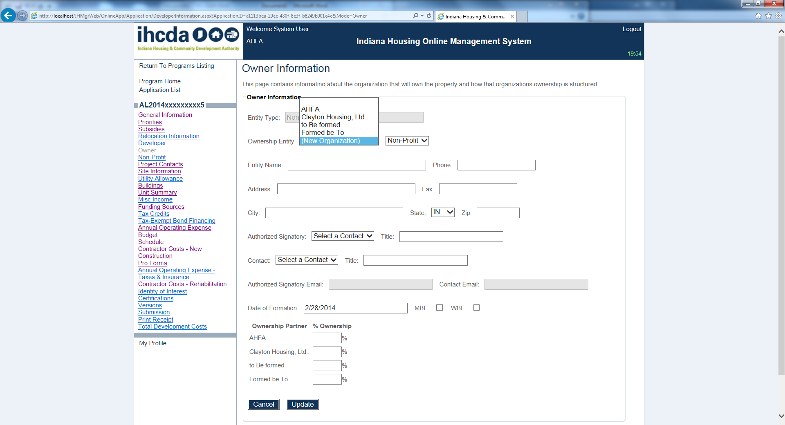

Step 2: Once you’ve selected “(New Organization)” the appropriate fields will become editable. Provide all applicable information on this page associated with the “To Be Formed” organization entity.
- At the bottom of the page, a user will have the ability to designate ownership percentages for any Affiliated Organization of their current organization. (As shown below).
- Once complete, click Update.

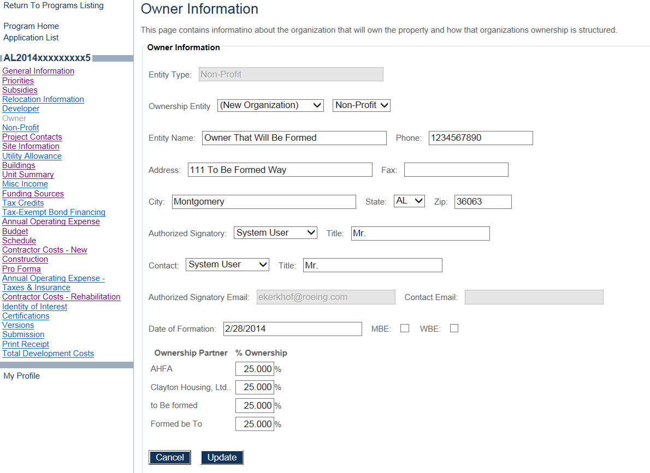

(Step 2 Continued)

- This user who created the “To Be Formed” organization entity as described will now be linked as a user to that “To Be Formed” organization.
- To access this “To Be Formed” organization, a user will need to be in his profile (Click on My Profile anywhere within the application). In the profile screen, click on Change. Organization located in the Profile section of the left navigation pane (as shown below).

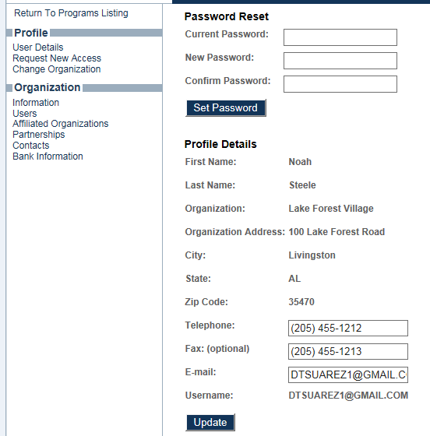

Step 3: Change Organization

- Click on the Drop Down menu and select your “To Be Formed” organization that you created.
- Click Set.
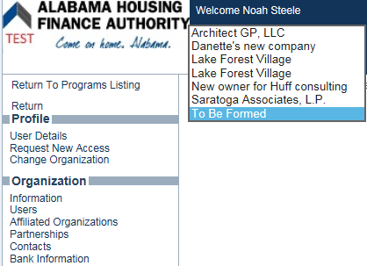

- Notice below that the Current Organization is now set to the “To Be Formed” organization entity. From here, the user will now have the ability to update affiliated organizations, partnerships and basic organization information for this To Be Formed organization entity.

